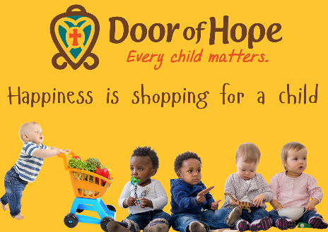

**Monthly Needs**

Thank you for enquiring about our monthly needs.

These are items we use daily and which we cannot do without

**Baby Foods**

Nan Optipro Formula 1 and 2

Baby Cereal Nestum, Nestle or Purity - all stages

Pureed Foods (Purity, Squish) - all stages

**Toddler Foods**

Weet Bix, Oats, Maltabella and Corn Flakes, Long Life Full Cream Milk

Tinned Foods- tuna fish, baked beans, chopped tomatoes, red kidney beans

Tomato puree, Stock cubes/powder, Dried Mixed Herbs, Mild Rajah Curry Powder

Maizemeal, Macaroni, Rice, Self-raising Flour, Sunflower Oil

Peanut Butter, Melrose Cheese Spread

**Toddlers Treats**

Long Life Custard, Marie biscuits, Cheese Curls and Raisins

Sugar, Rooibos Tea, Tea

**Kiddies Toiletries**

Nappies- Cuddlers, Pampers, Huggies sizes 3,4,5 and 6

Baby Wipes and Bum Cream

Baby Shampoo and Soap

**Hygiene & Home Needs**

Miltons Sterilising Liquid and Hygiene Hand Wash

Auto Washing Powder, Dish Liquid, Domestos, Jik and Handy Andy

Toilet Paper, Air Freshener and Tissues

Dischem, Pnp, Checkers Vouchers

**www.doorofhope.co.za**